**GREENWOOD COLLEGE**

**Mathematics Methods Unit 3**

**Test 3 Antidifferentiation & Integration 2020**

Name Mark /24

**All electronic devices must be switched off and in bags.  
Access to Formulae Sheet allowed. No notes.  
No calculators allowed in this section. Time limit 25 minutes.**

**1. [6 marks: 5, 1]**

A train is travelling at 30 metres per second when the brakes are applied. The velocity of the train is given by the equation 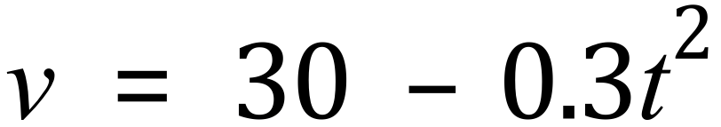 , where *t* represents the time in seconds after the brakes are applied.



The area under a velocity-time graph gives the total distance travelled for a particular time period.

(a) Complete the tables below and estimate the distance travelled by the train during the first six seconds by calculating the mean of the areas of the circumscribed and inscribed rectangles. (The rectangles for the 4–6 seconds interval are shown on the grid above.)



Estimate of total distance travelled………………………………metres

(b) Describe how you could better estimate the distance travelled by the train during the first six seconds than by the method used in part (a).

**2. [7 Marks: 3,1,1,2]**

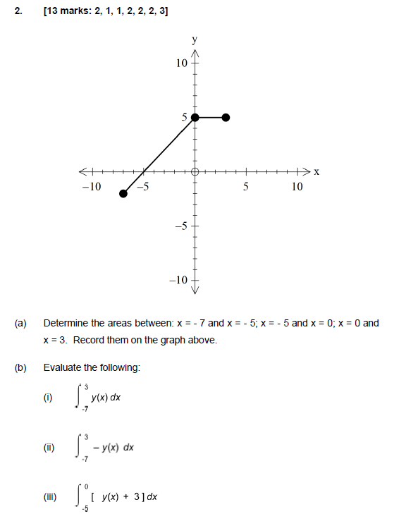

**3. [11 Marks: 3,3,3,2]**

(a) $\int_{0}^{1}{sin⁡(\frac{π}{6}})dx$

(b) ${\int_{-2}^{2}{2e}}^{3x}+6e^{2x}dx$

(c) $\int_{1}^{t^{2}}{\frac{d}{dx}\left(xe^{x}\right)dx}$

(d) $\int{-4\sqrt{1-3x}dx}$

**GREENWOOD COLLEGE**

**Mathematics Methods Unit 3**

**Test 3 Antidifferentiation & Integration 2020**

Name Mark /31

**All electronic devices must be switched off and in bags.  
Access to Formulae Sheet and one sheet of A4 notes allowed.   
Use of approved calculators is assumed in this section. Time limit 30 minutes.**

**1. [8 Marks: 4, 4]**

The accompanying diagram shows the graphs of $y=e^{x}$ and $y=2x\left(x^{2}-4\right).$

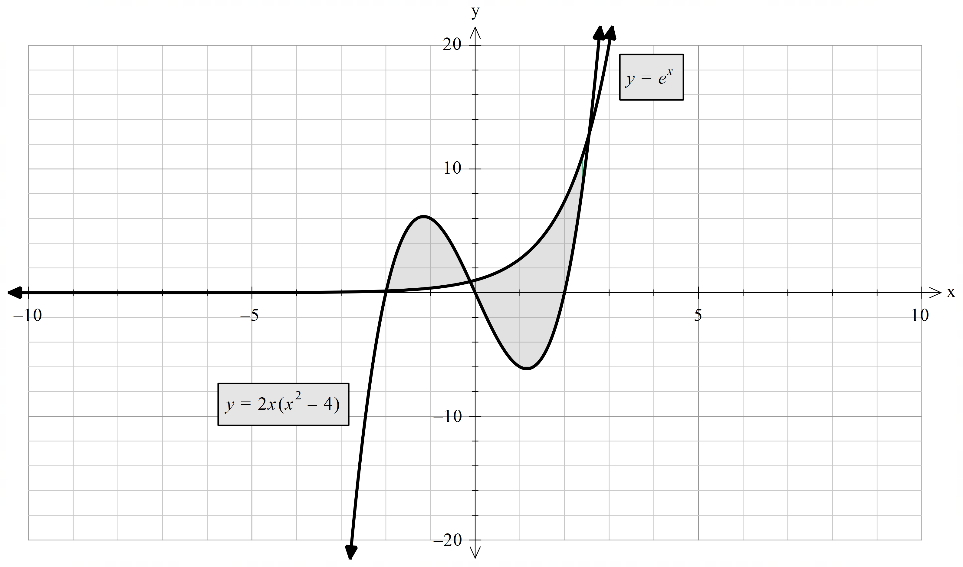

1. Write an integral that can be used to determine the area of the shaded region. Hence find the area of this region.
2. Write, but do not evaluate, an expression involving integrals that can be used to determine the area of the region trapped between the two curves, for $x≥0.$

**2. [6 marks: 4,2]**

An object is accelerating according to the function $a\left(t\right)=12t-8$ where t is the time in seconds.

If the initial velocity of the object is 2m/s and the initial displacement is 0m

1. determine the time/s when the object is at rest.
2. determine when the object returns to its start position.

**3. [4 marks]**

Use calculus to find the exact area of the region bound by $y=\sqrt{x}$ and $y=2-x$ and the x axis.

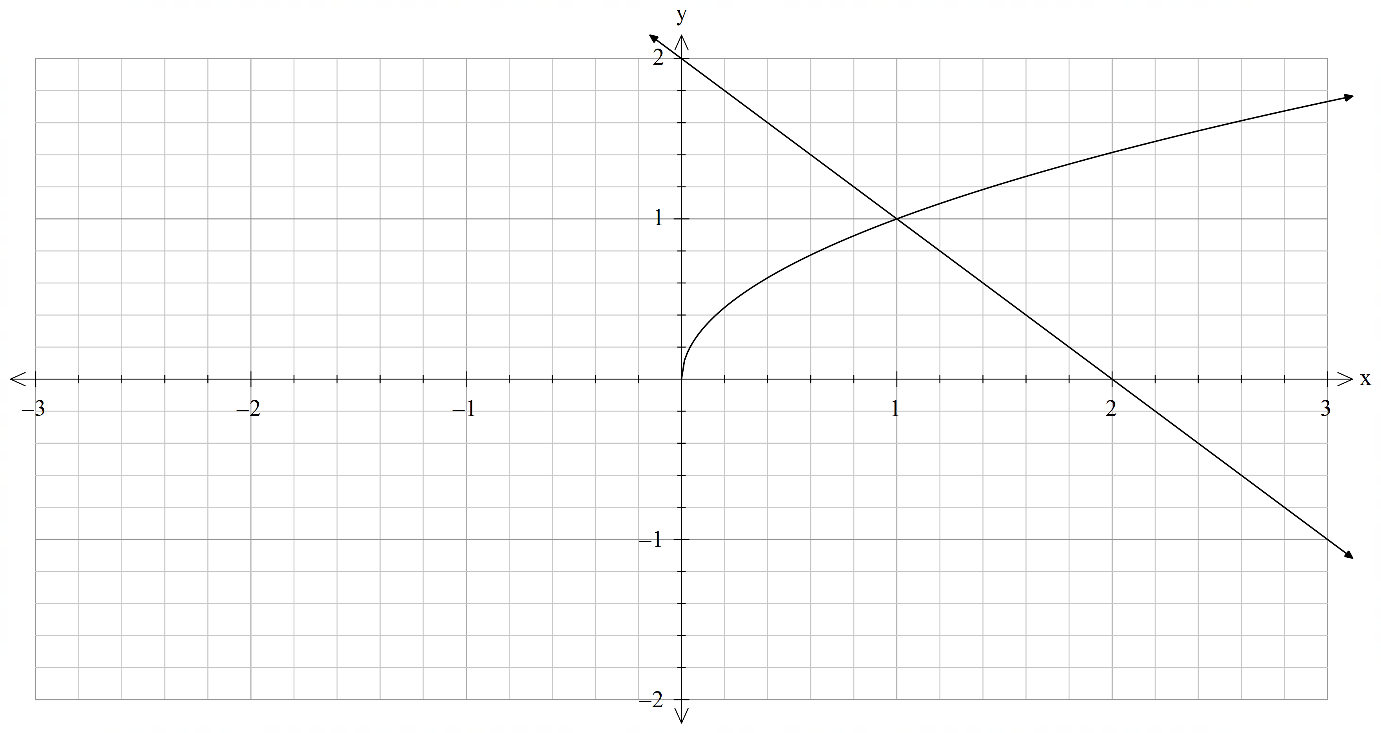

**4. [8 Marks: 2,2,4]**

Let $f(x)$ be a function such that $f\left(-2\right)=\frac{5}{2}, f\left(-1\right)=0, f\left(0\right)=-\frac{3}{2}, f\left(1\right)=-2$ and $f\left(3\right)=0$.

Further $f'(x)<0$ for - $2<=x<1$, $f’(1)=0$ and $f’(x)>0$ for $1<x<=3$

1. Evaluate the following definite integrals
$\int_{0}^{3}{f^{'}\left(x\right)dx}$

$\int_{-2}^{3}{f^{'}\left(x\right)dx}$

2. What is the area bound by the graph of $f'(x)$ and the $x$ axis between $x=-2$ and $x=3$. Justify your answer.

**5. [5 Marks: 3,2]**

The marginal cost for producing $x$ gadgets is given by $\frac{dC}{dx}= 3.15+0.0004x$ where $\$C$ is the cost of producing $x$ gadgets.

1. Given the fixed cost is $450, find the cost of producing 800 of these items.
2. Find the net change in cost if the number of items produced is changed from 1000 to 2000. Justify your answer.

**Topic 3.2 Integrals**

**Anti-differentiation**

3.2.1 identify anti-differentiation as the reverse of differentiation

3.2.2 use the notation $\int{f\left(x\right)dx}$ for anti-derivatives or indefinite integrals

3.2.3 establish and use the formula $\int{x^{n}dx=\frac{1}{n+1}x^{n+1}+c}$ for $n≠-1$

3.2.4 establish and use the formula $\int{e^{x}dx=e^{x}+c}$ (Q3 2 marks)

3.2.5 establish and use the formulas $\int{\sin{x}}dx=-cos{x}+c$ and $\int{\cos{x}}dx=\sin{x}+c$ (Q3 4 marks)

3.2.6 identify and use linearity of anti-differentiation (Q3b NC 2 marks)

3.2.7 determine indefinite integrals of the form $\int{f\left(ax-b\right)dx}$ (Q3 2 marks)

3.2.8 identify families of curves with the same derivative function

3.2.9 determine $f\left(x\right),$ given $f'\left(x\right)$ and an initial condition $f\left(a\right)=b$

**Definite integrals**

3.2.10 examine the area problem and use sums of the form $\sum_{i}{f\left(x_{i}\right) δx_{i}}$ to estimate the area under the curve $y=f(x)$ (Q1 NC 7 marks)

3.2.11 identify the definite integral $\int_{a}^{b}{f\left(x\right)dx }$ as a limit of sums of the form $\sum_{i}{f\left(x_{i}\right) δx_{i}}$

3.2.12 interpret the definite integral $\int_{a}^{b}{f\left(x\right)dx }$ as area under the curve $y=f\left(x\right)$ if $f\left(x\right)>0$ (Q3 4 marks)

3.2.13 interpret $\int_{a}^{b}{f\left(x\right)dx }$ as a sum of signed areas (Q2 NC 11 marks)

3.2.14 apply the additivity and linearity of definite integrals (Q3b NC 3 marks)

**Fundamental theorem**

3.2.15 examine the concept of the signed area function $F\left(x\right)=\int_{a}^{x}{f\left(t\right)dt}$

3.2.16 apply the theorem: $F^{'}\left(x\right)=\frac{d}{dx}\left(\int_{a}^{x}{f\left(t\right)dt}\right)=f\left(x\right)$, and illustrate its proof geometrically (Q3c 1 Mark)

3.2.17 develop the formula $\int_{a}^{b}{f'\left(x\right)dx=f\left(b\right)-f(a)}$ and use it to calculate definite integrals (Q4 CA 8 Marks)

**Applications of integration**

3.2.18 calculate total change by integrating instantaneous or marginal rate of change (Q5 CA 5 marks)

3.2.19 calculate the area under a curve (Q3 CA 4 marks)

3.2.20 calculate the area between curves (Q1 CA 8 marks)

3.2.21 determine displacement given velocity in linear motion problems (Q2 CA 2 marks)

3.2.22 determine positions given linear acceleration and initial values of position and velocity. (Q2 CA 4 marks)